NAME : B.Praneeth
REG NO : 192472222
COURSE CODE : CSA1678
SUBJECT : Data Warehousing and Data Mining for Cluster Analysis
FACULTY : Dr.P.Subramanian
Dr.M.Rajasekar
LAB OUTPUTS
Ex-1:
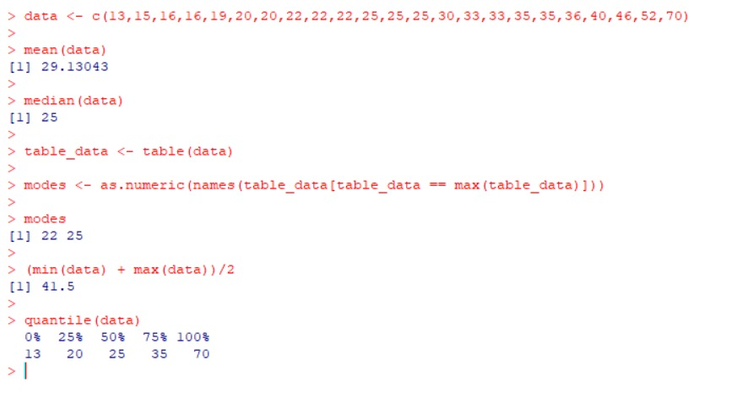
Ex-2:
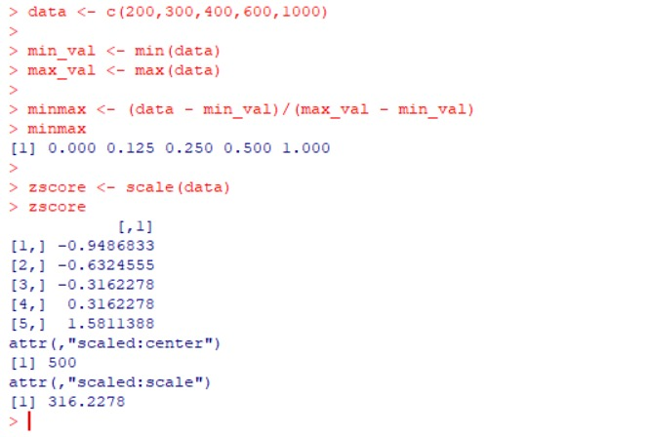

Ex-3:
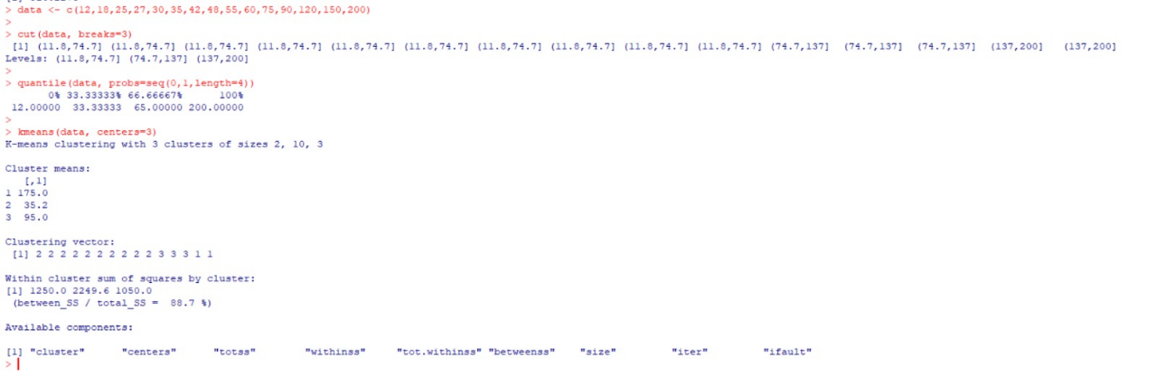

Ex-4:
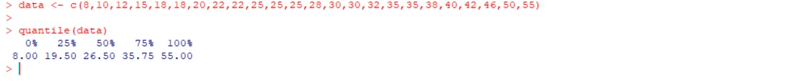
Ex-5:
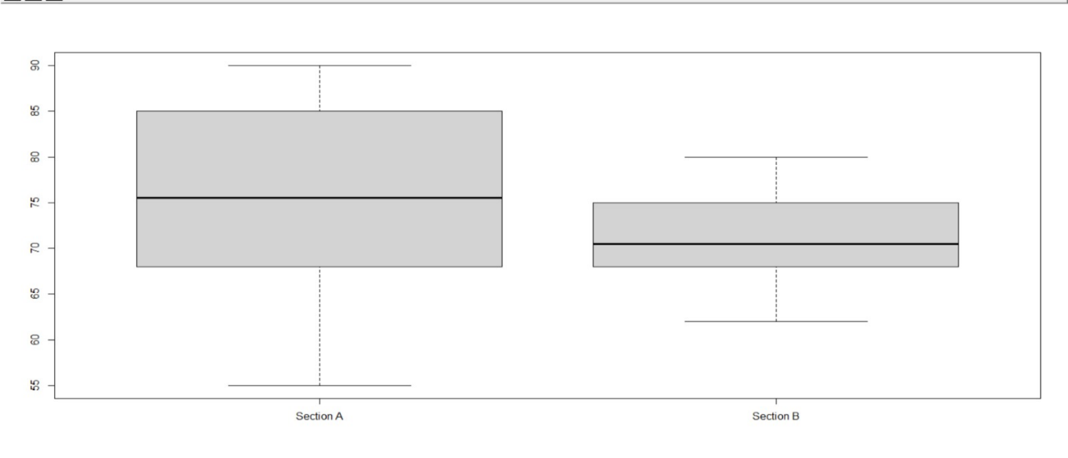
Ex-6:
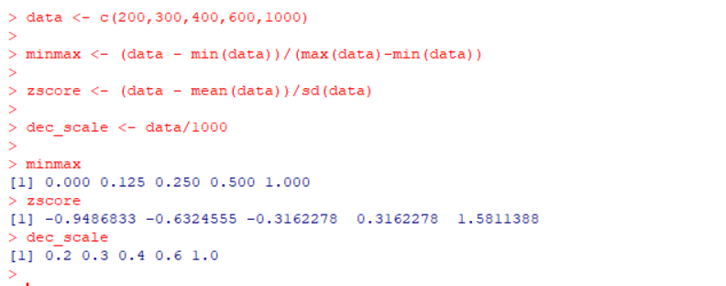
Ex-7:
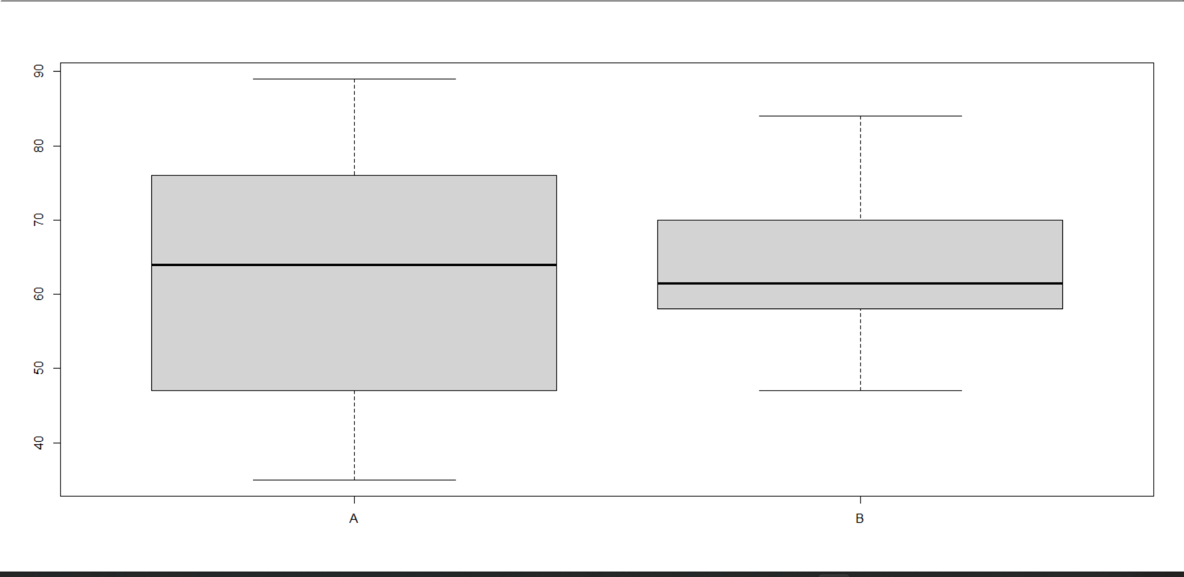
Ex-8:
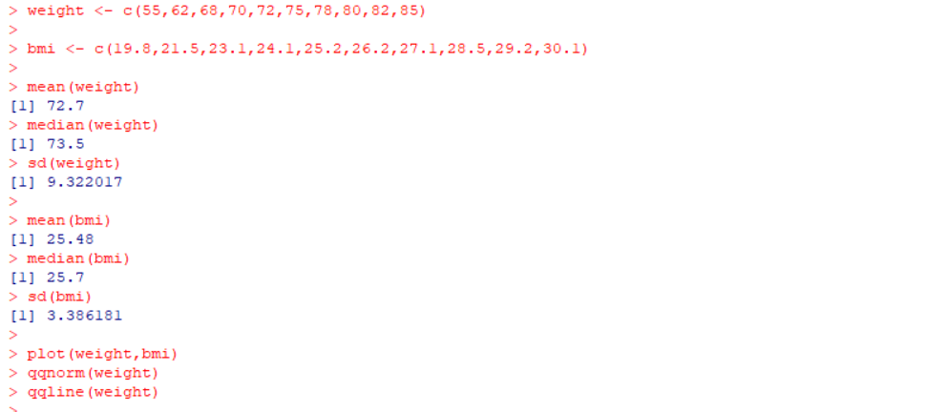
Ex-9: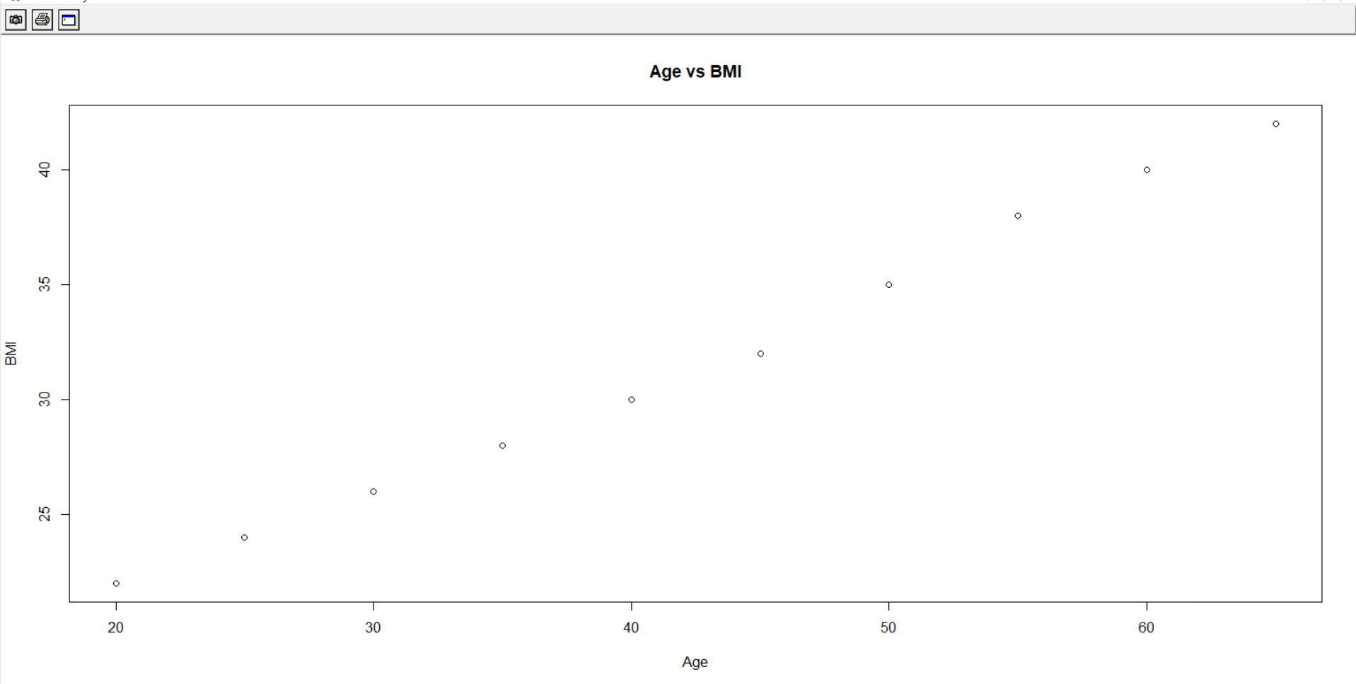

Ex-10:
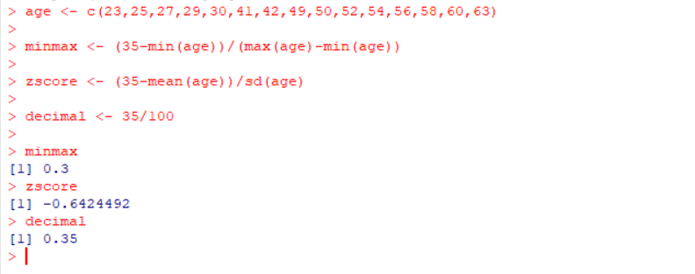

Ex-11:
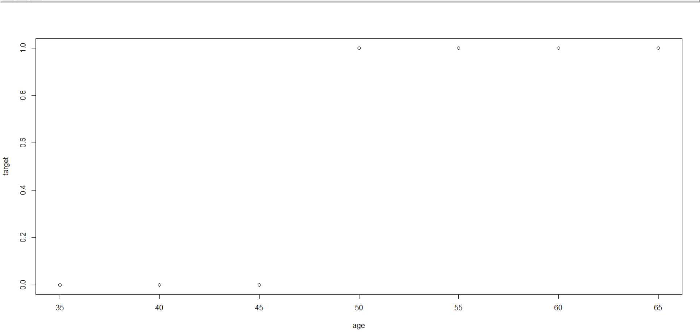
Ex-12:
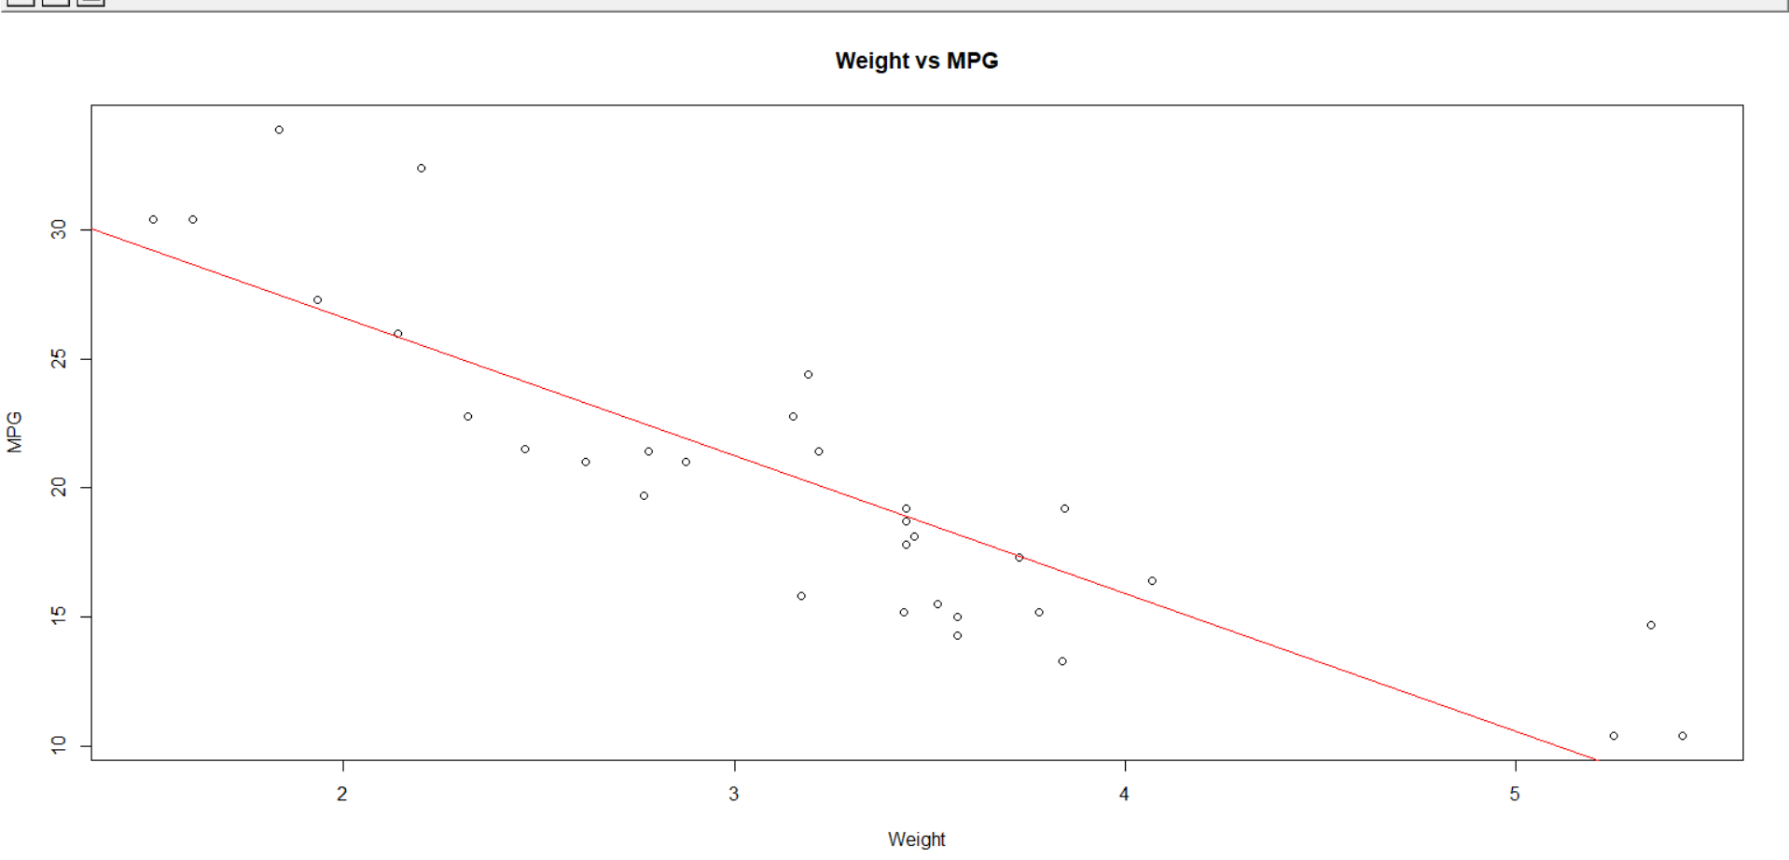

Ex-13:
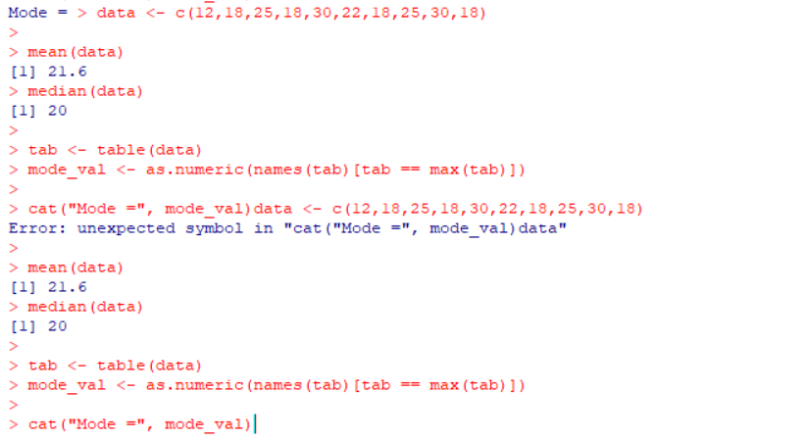
Ex-14:
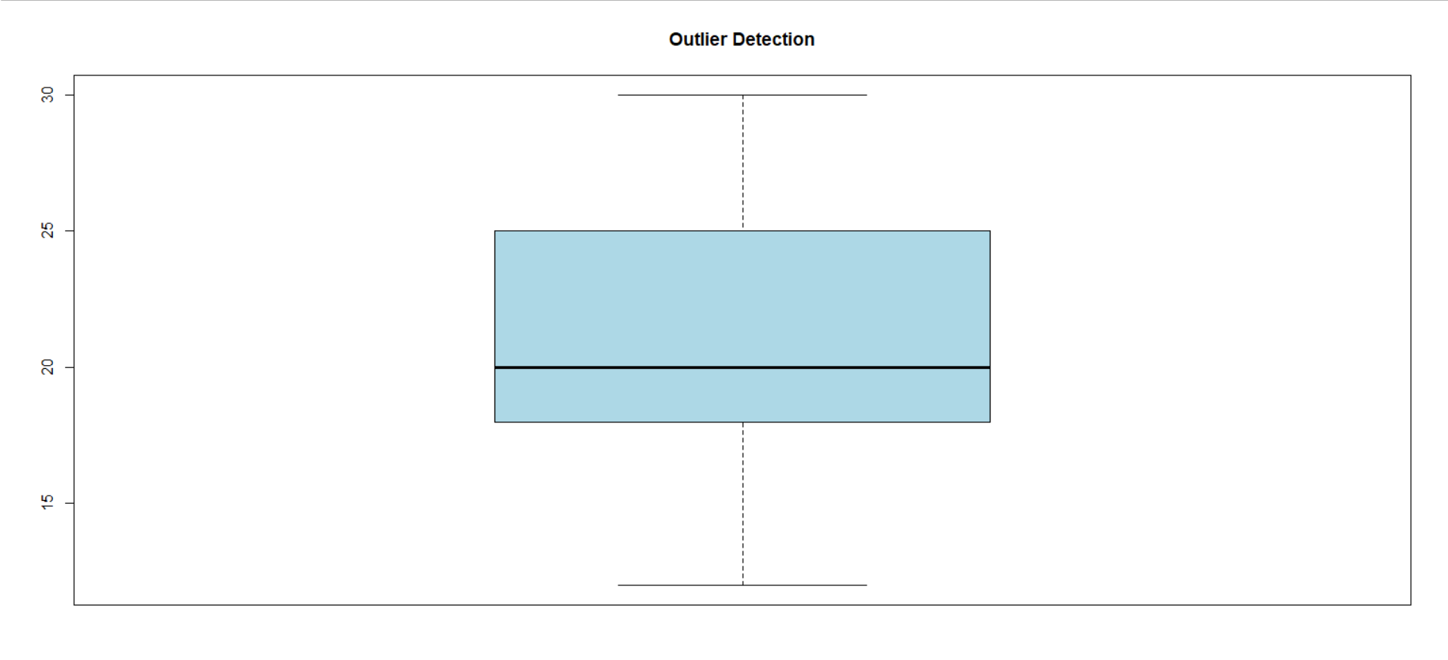
Ex-15:
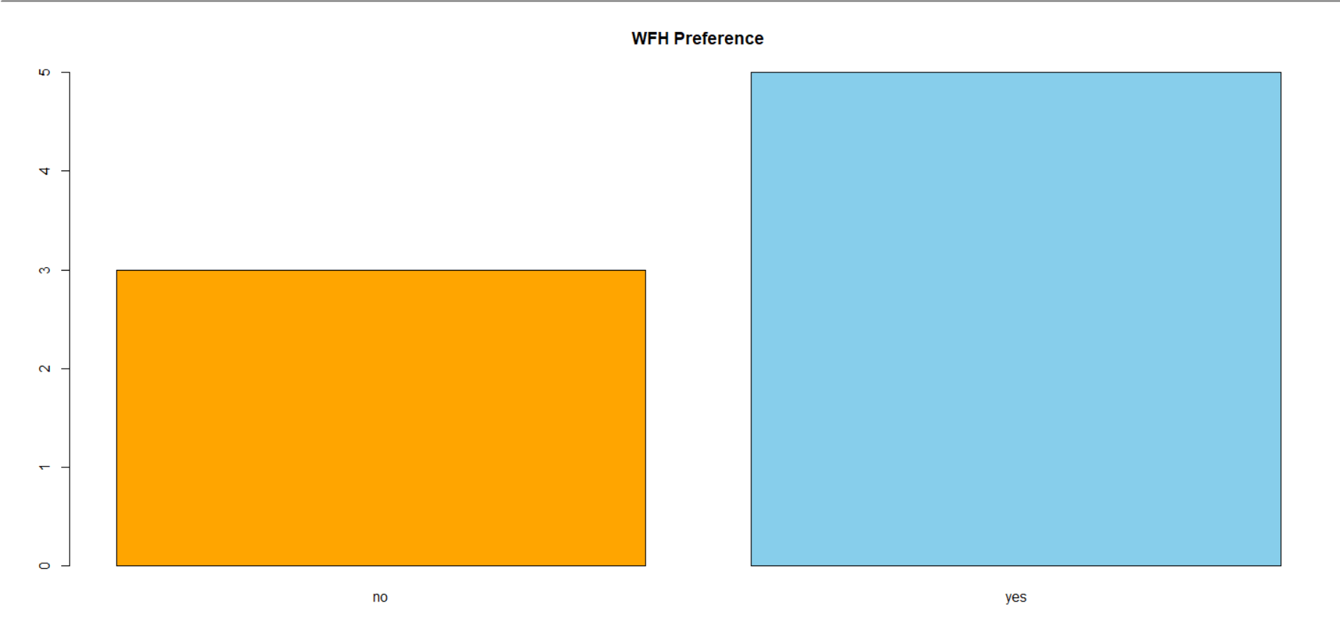

Ex-16:
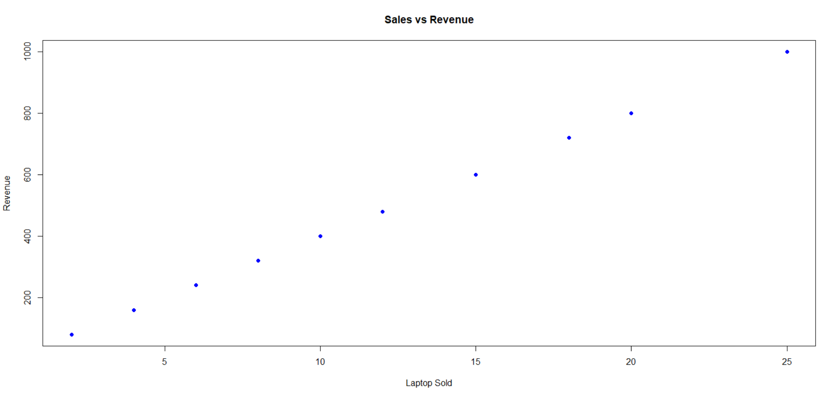
Ex-17:
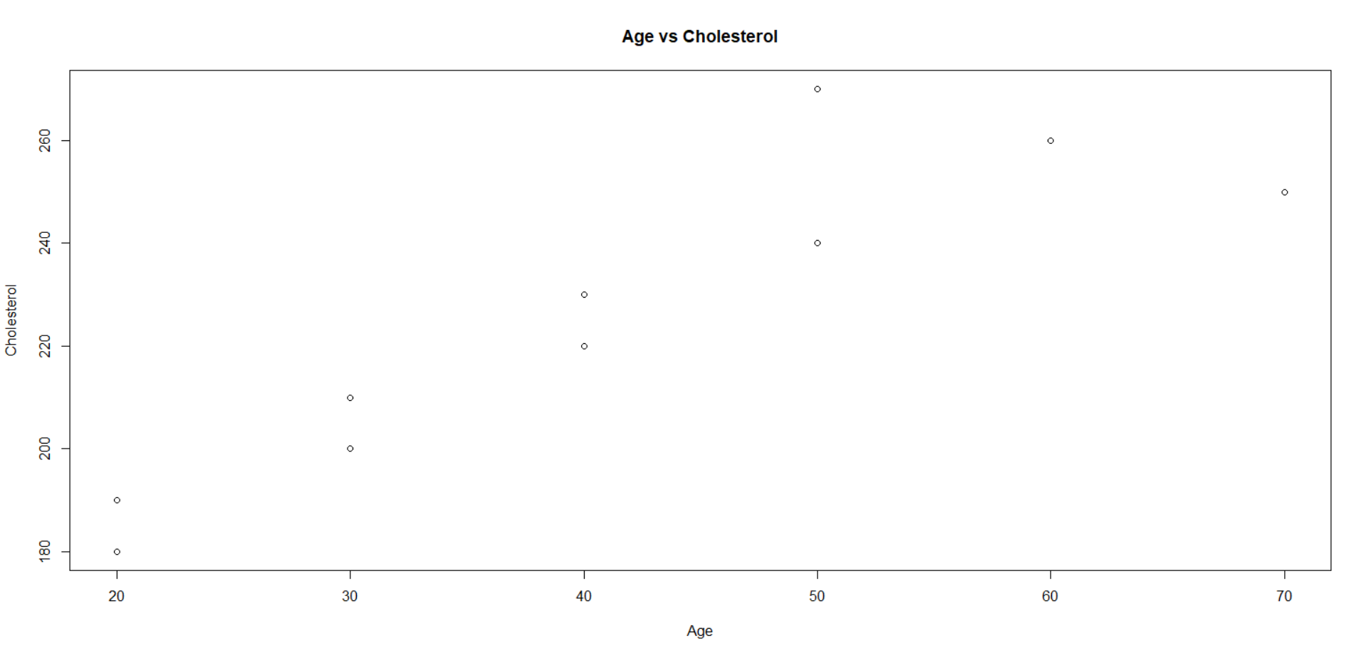
Ex-18:
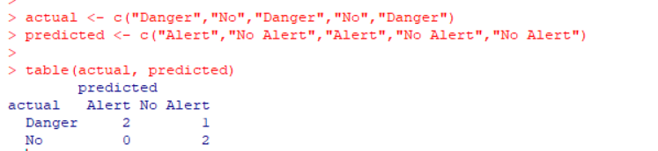
Ex-19:
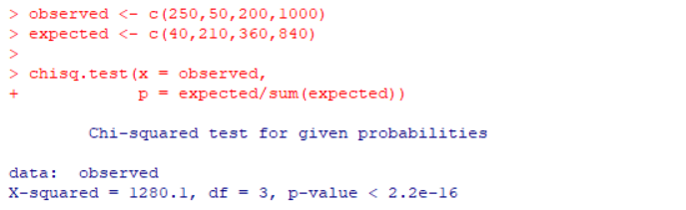

Ex-20:
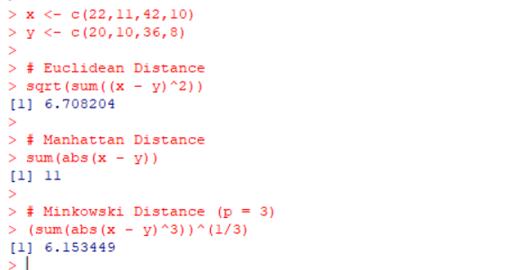

-----COMPLETED-----

